

**Proposal**

**For**

**DESIGN, DEVELOPMENT, HOSTING AND MAINTENANCE OF PRAAPTI WEB PORTAL and MOBILE APPLICATION**

**Submitted To: 9th Floor (A Wing), Statesman House Barakhamba Road Connaught Place,   
New Delhi – 110001**

**Submitted By:**

**M/s. NetCreativeMind Solutions Pvt. Ltd.**

**(Empanelled with NICSI vide Empanelment**

**No - 10(32)/2021-NICSI dated: 23/09/2022)**

**Table** **of Content**



[1 Proposed Solution 15](#_Toc176530161)

[1.1 Features Covered 15](#_Toc176530162)

[**1.1.1** Software Development 15](#_Toc176530163)

[1.1.1.1 User Management Module 15](#_Toc176530164)

[1.1.1.2 Dashboard Module 16](#_Toc176530165)

[1.1.1.3 Clothing Management Module 16](#_Toc176530166)

[1.1.1.4 Workflow and Process Management Module 17](#_Toc176530167)

[1.1.1.5 Stock and Inventory Management Module 18](#_Toc176530168)

[1.1.1.6 Reporting and Analytics Module 18](#_Toc176530169)

[1.1.1.7 Auditing and Compliance Module 19](#_Toc176530170)

[1.1.1.8 Notification and Alert Module 19](#_Toc176530171)

[1.1.1.9 Permissions and Access Management Module 20](#_Toc176530172)

[1.1.1.10 Performance Monitoring & Optimization Module 20](#_Toc176530173)

[1.1.1.11 Feedback & Issue Resolution Module 20](#_Toc176530174)

[1.1.1.12 Data Backup & Recovery Module 20](#_Toc176530175)

[1.1.1.13 Master Data Management (MDM) Module 20](#_Toc176530176)

[**1.1.2** Certifications 21](#_Toc176530177)

[1.1.2.1 Safe to Host Certificate 21](#_Toc176530178)

[1.1.2.2 SSL certificate 21](#_Toc176530179)

[1.1.2.3 Security Audit 21](#_Toc176530180)

[**1.1.3** Onsite manpower 21](#_Toc176530181)

[**1.1.4** Operations & maintenance 21](#_Toc176530182)

[1.1.4.1 What is covered in AMC? 22](#_Toc176530183)

[1.1.4.2 What is not covered in AMC? 22](#_Toc176530184)

[1.2 Features not covered 23](#_Toc176530185)

[1.3 Proposed Solution Architecture 23](#_Toc176530186)

[1.4 Technology 23](#_Toc176530187)

[**1.4.1** Development Environment 23](#_Toc176530188)

[**1.4.2** Hosting Environment 24](#_Toc176530189)

[1.5 Prerequisites for the Project 24](#_Toc176530190)

[1.6 Assumptions & Dependencies 25](#_Toc176530191)

[1.7 Project Deliverables 25](#_Toc176530192)

[1.8 Project Schedule 25](#_Toc176530193)

[2 Project Management 27](#_Toc176530194)

[2.1 AGILE WEB DEVELOPMENT Life Cycle 28](#_Toc176530195)

[2.1.1.1 THE KEY BENEFITS OF AGILE WEB/Portal DEVELOPMENT 31](#_Toc176530196)

[2.1.1.2 Project Management Tool to Streamline Workflow 32](#_Toc176530197)

[2.2 Change Management and it’s Process 33](#_Toc176530198)

[2.2.1.1 STEP INTO CHANGE MANAGEMENT 34](#_Toc176530199)

[2.2.1.2 Process Flow 36](#_Toc176530200)

[2.2.1.3 Governance Model 38](#_Toc176530201)

[2.3 Roles and Responsibilities 40](#_Toc176530202)

[**2.3.1** **Department** 40](#_Toc176530203)

[**2.3.2** **Agency** 40](#_Toc176530204)

[3 Appendices 41](#_Toc176530205)

[3.1 Format for Sample Progress Report 41](#_Toc176530206)

[3.2 Format for Content which is to be stored in a database 42](#_Toc176530207)

[3.3 Format for Content which is to be stored in pdf format 43](#_Toc176530208)

[3.4 Format for the completion certificate 44](#_Toc176530209)

[3.5 Format for Change Request 45](#_Toc176530210)

[3.6 Escalation Matrix 46](#_Toc176530211)

[3.7 Terms & Conditions 46](#_Toc176530212)

Revision History:

|  |  |  |  |  |  |
| --- | --- | --- | --- | --- | --- |
| **S.No** | **Date** | **Version No** | **Page No** | **Module** | **Brief Description of Change** |
| **1.** | **15-02-2025** | **1** |  |  |  |
| **2.** |  |  |  |  |  |



This document serves as a formal proposal for the design, development, implementation, and maintenance of an integrated web portal and mobile application for the Payment Ratification and Analysis in Power Procurement for Bringing Transparency in Invoicing of Generators (PRAAPTI) initiative by the Ministry of Power (MoP), Government of India. The goal of this project is to create a secure, scalable, and user-friendly platform that streamlines power purchase transactions, promotes transparency, and facilitates the effective implementation of the Late Payment Surcharge (LPS) Rules 2022.

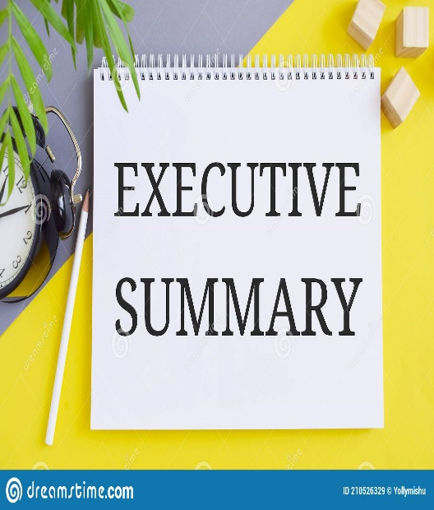

The proposed solution will enable comprehensive monitoring of the outstanding dues of Power Distribution Companies (DISCOMs) and Power Departments (PDs). It will feature an intuitive interface for all stakeholders, allowing for seamless entity registration, invoice management, payment tracking, dispute resolution, and reporting. The system will also incorporate advanced billing and revenue management features, API integration for financial transactions, and a centralized query redressal mechanism.

This project will ensure robust security measures and compliance with industry standards, including SSL certificates, data encryption, role-based access control, disaster recovery processes, and STQC certification. Furthermore, the hosting and database migration to MeitY-empaneled Government Community Cloud (GCC) will enhance the solution’s reliability and scalability

This proposal outlines our understanding of the requirements, along with the solution architecture, technical specifications, project phases, and timeline. It also covers the post-implementation support plan, training, and all necessary documentation to ensure a smooth and efficient project execution

**About US**



FOUNDED IN 2002, NetCreativeMind believes in professionalism providing immense- quality, timely and value-added assistance to clients.

We are a dynamic technology company that operates nationwide. Experience in delivering first-class IT solutions to various government departments and enterprise clients.

Completing 1000+ projects in IT and IT-enabled services. We are the first choice of 800+ clients in e-governance, Outsourcing, and staffing solution.



We are CMMI Level 3 certified company with ISO 9001:2015 and ISO 27001:2012 certifications. The company motto “Your Destination for perfection” reflects our dedication to serving our clients.

At NetCreativeMind, everything else takes backstage when client satisfaction comes into consideration.

****

Some of the Key STATS:



* Delivered more than 1000 Projects for Government and Corporate clients.
* We got the National Awards for Best Accessible Website in 3 Consecutive Years 2013, 2014, and 2015. Also “Web Ratna Award” in 2014.
* With over two decades of experience in managing the system and working of global enterprises, we expertly steer our clients through their digital journey. We also empower the business with agile digital at scale to deliver unprecedented levels of performance and customer delight.







National Informatics Centre Services Inc. (NICSI), India

Ministry of Electronics and Information Technology (MeitY), India



National e-Governance Division (NeGD), India



Press Information Bureau, India & Haryana State Electronics Development Corporation (HARTRON), Haryana

 



****

|  |  |  |
| --- | --- | --- |
| D:\Abida\Projects\Manpower presentation\mpagro.png | D:\Abida\Projects\Manpower presentation\himachal.png | https://upload.wikimedia.org/wikipedia/en/thumb/3/3a/PowerGrid_Corporation_of_India_logo.svg/814px-PowerGrid_Corporation_of_India_logo.svg.png |
| http://www.udyogbandhu.com/DataFiles/CMS/image/logoup.png | **https://upload.wikimedia.org/wikipedia/en/thumb/3/3a/PowerGrid_Corporation_of_India_logo.svg/814px-PowerGrid_Corporation_of_India_logo.svg.png** | **http://economictimes.indiatimes.com/photo/47893600.cms** |
| https://upload.wikimedia.org/wikipedia/commons/thumb/f/f4/Power_Finance_Corporation_Logo.svg/400px-Power_Finance_Corporation_Logo.svg.png | **http://negd.gov.in/writereaddata/files/NEGD-logo.png** |  |
| D:\Abida\Projects\Manpower presentation\mp code.png | **http://www.dgshipping.gov.in/App_Themes/standard/images/logo.png** | **D:\Abida\Projects\Manpower presentation\ayush.png** |
| https://scontent-hkg3-1.xx.fbcdn.net/hphotos-xpf1/v/t1.0-9/p720x720/15599_955848377781996_3918263499127813161_n.png?oh=7069d4fc93cc62660c948e684e7404cb&oe=5677F020 | **http://www.indianetzone.com/photos_gallery/87/Press_Information_Bureau_Indian_Production_House_1.jpg** | **http://ceoarunachal.nic.in/images/ECI.jpg** |
|  |  | **C:\Users\NCM\Desktop\logo\herclogo.png** |
| D:\Abida\Projects\Manpower presentation\child-dev.png | **D:\Abida\Projects\Manpower presentation\bureau.jpg** | **D:\Abida\Projects\Manpower presentation\itat_home_logo.jpg** |

**Our Services**





***ERP Development***

***Biometric & IRIS Devices***

***Cloud Hosting/SSL/DSC Certificates***

***Microsoft/Oracle/Adobe Software Licenses***

***Business Intelligence, Process Automation***

***Data Analytics Solutions***

***Re-engineering, Upgradation, Maintenance***

***Mobile Application Development***

***Website/Portal Development***

**Objectives**

   
  
The primary objective of this project is to modernize and enhance the PRAAPTI Web Portal and Mobile Application to align with industry best practices, ensuring transparency, accountability, and efficiency in the power procurement process under the Ministry of Power, Government of India. Specifically, the upgraded portal and application will enable real-time monitoring, central auditing, and improved user experience for all stakeholders involved in power purchase transactions. Key objectives include:.



* Ensure transparency in invoicing and payments, complying with Late Payment Surcharge (LPS) Rules, 2022..
* Improve portal and app with user-friendly design, bilingual support, and cross-platform accessibility, including support for differently-abled users..
* Implement role-based access control for stakeholders, tracking dues and payments for DISCOMs and Power Departments..
* Streamline processes with features like entity registration, invoice management, payment recording, bulk uploads, automated notifications, and query redressal.



* Enhance dashboards for graphical data, customized reports, and MIS-based decision-making.
* Implement robust data protection, SSL encryption, role-based controls, API security, virtual firewalls, and disaster recovery.Application Generates customized reports.
* Migrate to MeitY-empanelled GCC with development, testing, and production environments, backups, disaster recovery, and domain mapping.

**Benefits**



* **Enhanced Transparency**
* **Centralized Invoice & Payment Management**
* **Modernized User Experience**
* **Increased Stakeholder Access**
* **Cross-Platform Accessibility**
* **Ease of Navigation**



* **Time & Cost Savings**
* **Tracking & Monitoring**
* **Admin & Mobile Functionality**
* **Mobile-Friendly & Responsive**
* **Faster Load Times**
* **Stakeholder Engagement**
* **Relationship Building**.

# Proposed Solution

## Features Covered

Web Portal & Mobile App development

#### User Management Module

##### Entity Registration and Role-Based Access

* Users register on the portal with different roles: Generators, DISCOMs, Administrators, and PFCCL.
* Role-based access controls ensure users can only access relevant data and features.

##### Secure Login with OTP

We propose Multi-factor authentication (MFA) with OTP-based verification ensures secure user access

##### CMS for Admin Control Panel

We propose a Centralized content management for the portal.Administrators can add or modify static and dynamic content, including notifications and user instructions.

#### **User Interface (UI) and User Experience (UX) Enhancements**

to provide a user-friendly and accessible portal experience

* **Modern UI**: Developed using HTML5, CSS3, Bootstrap, and the latest frameworks.
* **Bilingual Support**: English and Hindi language options.
* **Accessible Design**: WCAG-compliant for disabled users.
* **Unicode-Compliant Font**: Ensures language compatibility across all browsers.
* **Fluid Layout**: Auto-adjusts page layouts for desktop, mobile, and tablets.
* **Home Page Customization**: Allows for promotional messages or announcements.
* **Page Load Time**: Ensures home page and major pages load within 2-3 seconds.
* **Navigation Efficiency**: Minimal clicks required to find critical information

#### Billing and Revenue Management

We propose to facilitate billing, invoicing, payment collection, and revenue management in the PRAAPTI Portal.

##### Invoice module

* **Entity Registration**: Enables DISCOMs and suppliers to register securely.
* **Invoice Uploading**: Suppliers can upload invoices with automated validations.
* **Invoice Approval**: DISCOMs can approve/reject invoices with comments.
* **Payment Recording**: Allows DISCOMs to record payments.
* **Dispute Management**: Enables suppliers to raise invoice disputes and track resolutions.
* **Bulk Invoice Upload**: Allows multiple invoices to be uploaded at once.
* **Transactional Mailers and OTP Verification**: Automated email alerts for each invoice step and OTP-based validations for secure actions.

##### Revenue management system

* **Annual Subscription Charges**: PFCCL can generate invoices based on annual subscription/Portal usage.
* **GST e-Invoice Generation**: Auto-generate GST e-invoices with IRN and QR codes using NIC’s invoicing system.
* **Payment Gateway Integration**: Supports multiple payment methods for user payments.
* **ERP Integration**: Seamless integration with PFCCL’s SAP/ERP system via APIs for financial transaction updates.
* **Reports and Alerts**: Comprehensive reporting and alerts for overdue payments or outstanding dues.

#### Centralized Query Redressal & Monitoring

We propose a centralised query redressal module

* Track the lifecycle of queries from submission to resolution.
* Log all interactions and updates for auditing
* Generate detailed reports showing the number of received, resolved, and pending queries.

#### Reporting and Dashboard (MIS Reports) Module

We propose to provide actionable insights through robust reporting mechanisms.

* **Graphical Analytics**: Displays critical metrics in pie charts, bar graphs, and trend lines.
* **Downloadable Reports**: Data export options in Excel, PDF, CSV, and text formats.
* **Centralized Log**: Tracks all user queries with timestamps.
* **MIS Reports**: Provides breakdowns of resolved, pending, and escalated queries.
* **Web Traffic Reports**: Analyzes visitor traffic, session times, and bounce rates.
* Automated daily data backups to ensure data integrity.
* Maintain logs of all user activities with timestamps.

#### Security and Data Protection Module

We propose a to safeguard data integrity and ensure secure access control.

**1. User Authentication**

* **Secure Logins**: Implements strong password policies and multi-factor authentication.
* **Role-Based Access Control**: Restricts access to sensitive functions based on user roles.

**2. Data Protection**

* **Encryption**: All user data is encrypted during storage and transmission.
* **API Security**: Ensures secure data exchange between the portal and third-party systems.

**3. Network Security**

* **SSL Certificates**: Ensures encrypted communication.
* **Firewall and IDS/IPS**: Intrusion prevention systems for detecting and preventing unauthorized access.
* **Anti-virus and Malware Scanning**: Regular scans of the server environment.

**4. Backup and Disaster Recovery**

* **Regular Backups**: Daily backups stored on a segregated server.
* **Disaster Recovery Plan**: Rapid database restoration in case of data corruption or breaches.

#### Database Management Module

We propose a high-performance database management system capable of handling large data volumes and real-time data loads. Data migration processes will include proper validations, tracking, reporting, and correction procedures. Archival categorization (public/private) and date-based filtering will be implemented to enhance data retrieval and management efficiency.

* **High-Volume Real-Time Data Loading**: Database architecture designed to handle large data loads efficiently.
* **Data Migration Validations and Reporting** : Validate and report errors during data migration to ensure data accur
* **Archival Categorization and Retrieval** :Categorize data as public or private for easy retrieval.
* **Date-Based Filtering**: Enable filtering and searching of records based on date ranges.

#### API Integration Module

* **Integration with NIC Invoicing Portal and SAP/ERP**: Seamlessly integrate with external systems for invoicing and financial management.
* **Secure Data Exchange** : Ensure secure and reliable data exchanges through APIs.

#### Archive Management

We propose to categorize and manage historical records. We propose a robust archival system that will securely store historical invoices and transactional records. Users will be able to filter data based on date or category, ensuring quick retrieval of relevant information while maintaining compliance with data retention policies.

* **Public Archives**: Accessible to all users.
* **Private Archives**: Restricted to authorized users.
* **Admin Categorization**: Admins can move data between public and private archives.

#### Site Search Module

We propose to provide efficient site-wide search functionality. We propose implementing advanced site search capabilities to help users quickly locate invoices, reports, or relevant content using keyword searches. The search results will display links to detailed pages, improving navigation efficiency.

* **Keyword-Based Search**: Search across all database-driven content.
* **Search Result Listings**: Displays links to relevant pages with highlighted keywords.

#### Admin Module

1. **Centralized Portal Management:** Allow administrators to manage all aspects of the portal from a single interface.
2. **Content Management Control:** Manage site content, including announcements and informational updates.
3. **Traffic and Performance Monitoring** :Monitor portal traffic and performance metrics.

#### Content Management System

to provide admins with control over site content.

* **Admin Control Panel**: Role-based access to modify and publish content.
* **Page Content Optimization**: proper formatting for accessibility.
* **Promotional Content Management**: Enables homepage customization for promotional announcements.

#### Non-Functional features

**1. Performance:** High availability and scalability to handle peak traffic.Ensure page load times of 2-3 seconds or less.

**2. Security:** Implement SSL, virtual firewalls, sandboxing, IDS/IPS, and WAF.Conduct regular security audits to identify and mitigate vulnerabilities.

**3. Backup & Disaster Recovery:** Regular backups and a disaster recovery plan to ensure data availability.

**4. Compliance:** Ensure Unicode compliance and adherence to Government of India guidelines.

**5. Accessibility:** Bilingual support for English and Hindi.Cross-browser and platform compatibility.Mobile responsiveness and support for differently-abled users.

#### Miscellaneous Features

Video Editing & Animation   
Capability of integration with other Portal

Hosting & Migration

The proposed hosting and migration plan will ensure the PRAAPTI Portal operates in a secure, high-performance, and resilient environment, fully aligned with government standards and best practices. The fresponsibilties proposed are as follows

* Successfully migrated PRAAPTI Portal to MeitY-empanelled GCC.
* Domain mapping and application hosting completed.
* Backup and restore mechanisms implemented.
* Suitable security arrangements in place.
* Disaster recovery plan tested and documented.
* Regular environment reviews and performance reports.

The steps are for hosting & migration are as follow

1. **Environment Setup:**
   * Creation of Sandbox, Development, Test, and Production instances.
   * Ensure proper configuration of all instances to ensure data integrity and application stability.
2. **Domain Mapping:**
   * Map the domain name of the current PRAAPTI Portal to the updated IP address of the new PRAAPTI Application.
   * Host the newly developed application under the mapped domain.
3. **Data Backup & Restore:**
   * Establish a regular backup and restore mechanism for the entire application, including databases and file systems.
   * Schedule automated backups and test restore functionality periodically to ensure data integrity and minimal downtime.
4. **Security Arrangements:**
   * Implement suitable security measures to ensure data protection and compliance with government regulations.
   * Security arrangements include:
     + SSL certificates for encrypted data transmission.
     + Virtual Firewalls, Web Application Firewalls (WAF), Intrusion Detection Systems (IDS), and Intrusion Prevention Systems (IPS).
     + Role-based access control for secure access to various environments.
     + Data encryption at rest and in transit.
     + Periodic vulnerability scans and penetration tests.
5. **Continuous Disaster Recovery Processes:**
   * Establish disaster recovery processes for all environments (Development, Testing, Production).
   * Maintain geographically distributed backups for disaster recovery scenarios.
   * Conduct regular disaster recovery drills and maintain a disaster recovery plan for minimal business disruption.

The hosting infrastructure will be provided using MeitY-empanelled GCC services for application hosting, database hosting, and file server hosting.

1. **Environment Segregation:**
   * Provide three (3) separate environments:
     + **Development Environment:** For development and integration activities.
     + **Testing Environment:** For rigorous testing and QA activities.
     + **Production Environment:** For live application hosting and user access.
2. **High Availability:**
   * Ensure all instances are hosted in a highly available and redundant infrastructure to minimize downtime.
   * Implement load balancing to distribute traffic and optimize application performance.
3. **Performance Monitoring:**
   * Continuous monitoring of the environment for performance, security, and availability.
   * Generate periodic reports to track performance metrics and incidents.
4. **Periodic Reviews:**
   * Conduct regular reviews of the infrastructure and application to ensure compliance with best practices and government guidelines.
   * Identify and address any potential bottlenecks or vulnerabilities.

Operation and Maintenance of the Portal & Mobile application

#### Manpower Deployement

We propose to deploy two (2) full-time resources on-site at PFCCL HQ, Delhi:

* **Resource 1:** Senior Developer with seven (7) years of experience in web portal and mobile application development, maintenance, and testing using the proposed technology stack/platform.
* **Resource 2:** Developer with three (3) years of relevant experience in similar domains.
* Both resources will hold a BE/B.Tech./MCA degree (or equivalent/higher) and will bring their own laptops equipped with all necessary tools.

#### what is covered in AMC

* Continuous software operations and availability.
* Timely execution of all configuration tasks in case of software corruption, equipment failure, or PFCCL’s change requests.
* Maintenance activities during the warranty and O&M period are completed within the specified timeline
* Implement, test, and document any changes, additions, or modifications requested by PFCCL for the Web Portal and Mobile Application.
* Ensure the accurate and timely implementation of changes in both English and Hindi versions as per PFCCL-defined timelines.
* Ongoing maintenance of all portal and mobile application content.
* Resolution of usability and compatibility issues to ensure optimal user experiences.
* Ongoing telephonic and email support to assist authorized users with the Web Portal and Mobile Application.
* Training sessions or support calls to help users feel comfortable with the system’s functionality and updates.
* Analysis and resolution of issues encountered during actual usage of the portal and mobile application.
* Continuous monitoring and optimization to resolve performance-related issues.
* We will add new features and functionalities as requested by PFCCL to meet evolving business needs.
* Conduct quarterly preventive maintenance sessions and evaluate the hosting infrastructure.
* Provide detailed reports on maintenance activities and infrastructure performance.
* 24x7 Technical Assistance through email and phone.
* Fixing Security Vulnerabilities whenever any issue is reported or in the case of cyber-attacks.
* Training & Handholding of user representatives on Content Management System workflow on a demand basis.
* Addressing Server related issues to ensure application uptime by coordinating with the data center.
* Addressing Browser Compatibility related Issues to ensure the smooth functioning of the website on updated versions of all popular web browsers.
* Addressing Device Compatibility related Issues to ensure the smooth functioning of the application on all Personal Computers, Smart Phones, and Tablet PCs and disabled specific devices.
* Addressing application Performance related issues to fix issues like no response, slow response, website crashing, etc.
* Rectification of bugs we will fix all the security-related Bugs as per the recommendations of the Cyber Security Auditor for compliance & Issuance of a new audit certificate.
* Minor Changes like changing static images, text, updating and our privacy policy, site terms of use, disclaimers, etc.
* Implement monitoring tools to track system performance, identify potential issues, and ensure uptime.

Certififcations

1. STQC Certificate & Functional Audit Report
2. SSL Implementation certificate
3. CERT-IN Empanelled Secutity Audit

## **Out of Scope**

* Domain Registration
* Payment Gateway API
* Purchasing any Licenses Software like AI
* Integartion AI Data Analytical tool

## **Proposed Solution Architecture**

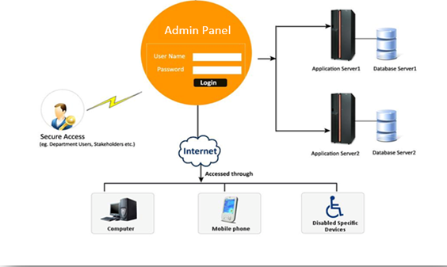

## **Technology**

### Development Environment

Ubantu,PHP Framework Laravel , MySQL and React Native

## **Prerequisites for the Project**

* + Department shall provide the list of the final requirements work order.
  + Department will need to restructure document (text, documents, images, audio, video, etc.) as per new Information.
  + Department should nominate Nodal Officer at the beginning of the project for-
* Requirement clarification
* Resolving the queries
* Regular review of deliverables
  + Department will provide complete correct required fields of form
  + Department should ensure that all the Images and media files are free from any copyright issues.
  + The department should ensure that all reviews are completed within 1 week of submission.
  + IA will be responsible for providing the staging server with the said configuration for the necessary testing.
  + Department would be responsible for arranging the hosting server.
* Department would also be responsible for approval of the site map, home page design, and SRS.

## **Assumptions & Dependencies**

* Documents – development will be done according to the formats mentioned in IA.
* Push notifications will not work in case of no internet connectivity.
* Server details needs to clarified by department.
* The application would be launched only after the receipt of the completion certificate from the user.
* All the documentation (user manual) will be provided in soft copy in the English Language by email.

iverables and Schedule

## **Project Deliverables**

1.SRS Document

2.Detailed Project Plan, Functional Specifications and Design documents.

3.Ownership of all source code

4.Data Migration Document

5.Technical Manuals, User Manuals and Training material

6.CERT-IN Empanelled STQC audit &Functional Audit Report

7.Data Backup / Archival process

8.FAQ and web Portal & Mobile Application policy

9. Security Audit

10. SSL certificate

11. Strictly comply to all national and international copyright, IPR and trademark requirements for all content available

12.Non-disclosure agreement

13.Training & Support

## **Project Schedule**

the job is to be completed within 28 weeks ( 7 Months ) days from the date of issue of job/ work order.

|  |  |  |  |  |
| --- | --- | --- | --- | --- |
| Phase | Milestone | Activities Covered | Duration | |
| Item-wise timelines | Overall |
| Phase - I | New Application(s) Development (Mobile Application and Web Portal including RMS) | i) SRS and Design Documentation ii) Appoint Third Party Auditor for audit of Application & hosting arrangement | 2 weeks | 22 weeks from date of award |
| iii) Submission of PERT chart for scheduled activities of Phase I & Phase II v) Development of new web Portal & Mobile Application | 20 weeks |
| Phase – II | Cloud Resource Provisioning: Compute, Storage with required Cyber Security arrangement. Hosting, Audit and Handover | i) Provisioning of Cloud instances Sandbox, Development & Test on MeitY empaneled GCC | 2 weeks | (During the period of Phase – I) |
| ii) Domain management activities | 3 weeks (Prior to production) |
| iii) UAT of Portal & Mobile Application and any possible mitigation of observations | 2 weeks immediately after development is complete | 6 weeks after completion of Phase-I |
| iv) Provisioning of Production instance on GCC. |
| v) Hosting of new Applications | 1 week |
| vi) Database migration from the existing server to the new server | 2 week |
| vii) Completion of Web Portal and Mobile Application’s Security Audit by CERT-IN empaneled agency | 2 week |
| viii) Handing over of the complete source code, System Manuals, User Manuals and final as well as functional web Portal & Mobile Application to owner. 2 weeks | 2 week |
| ix) FAQ and Policy Drafting | 4 week |
| Phase III | Operations & Maintenance | i) Monthly Maintenance & Required modifications in the Portal as may emerge from time to time  ii) Sharing of Data backup and updated source code from time to time iii) Routine security audits for safety & security of web Portal/Mobile Application  iv) Updating FAQs from time to time |  | After Completion of Phase I & II) |

# Project Management



Project management is the use of specific knowledge, skills, tools, and techniques to deliver something of value to people. The development of software for an improved business process

Before an outcome is achieved, each aspect of a project must go through phases of initiation, planning, and execution. This process is known as the project management lifecycle, and it is the lifeblood of successful projects.

Moreover, this cycle allows project managers to plan each task and activity meticulously to ensure the highest chances of success. Overall, a project is a well-planned endeavour that follows a lifecycle with a definite beginning and end.

## AGILE WEB DEVELOPMENT Life Cycle

In agile, work is carried out in parallel and the process is flexible and welcomes change. It keeps impressing and drawing people in because it’s simple to the bone yet ludicrously effective. In short, it breaks projects down into a collection of smaller jobs which together make it complete.

With the detailed breakdown at hand, sprints are planned which deliver those tasks within a certain time frame. When a sprint ends, the client gets a finished part of the product, which is independent and functional:

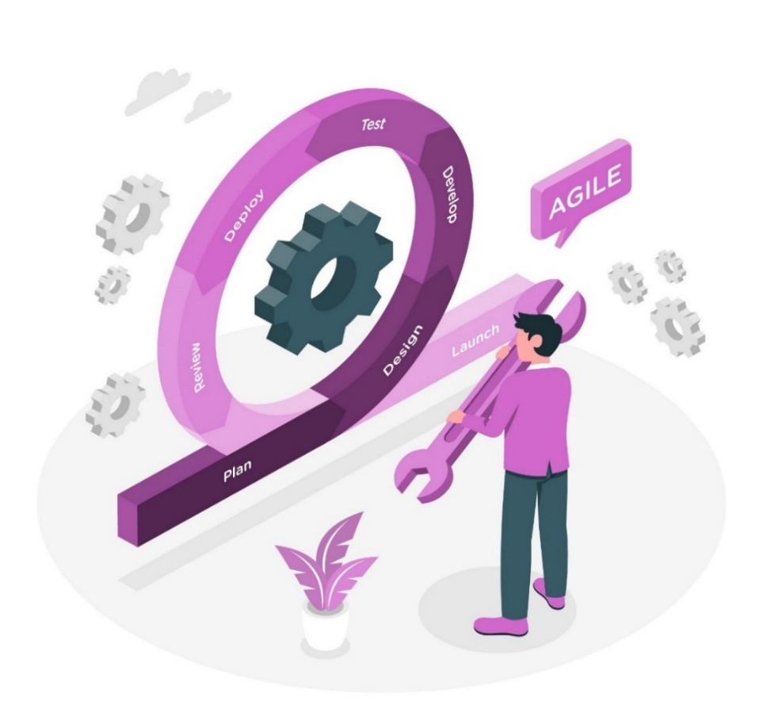

Stage 1: Ideation

All successful agile software/Web development projects begin with an ideation stage. Working closely with stakeholders, the business team, developers, and the future users of the app, the agile product owner pieces together the vision for the project by:

* *Defining the purpose and goal of the new software*
* *Determining and documenting business and user requirements*
* *Prioritizing tasks and allocating resources*

Phase 2: Designing

The Web/Software owner meets with the development team and introduces them to the requirements outlined in the first step.

The group then discusses the sequence for introducing functions and identifies the essential tools – the programming language, syntax libraries, and basic frameworks.

At the same stage, software/Web development teams can prototype the expected user interface

Phase 3: Development and coding

After agreeing on the plan with the customer, the team develops the product/Web Application itself. The product is delivered in stages, in separate sprints, each designed to improve the current version of the product. The initial release is likely to undergo many changes to provide improved functionality and new features.

Each cycle includes testing, and the final product must also undergo final testing. For this phase, you can use Scrum and the Kanban methodology, the development process based on individual tasks.

Phase 4: Integration and testing

At this point, the product becomes available to consumers, so the team must conduct a series of tests to ensure that the software/Web Application is fully functional. If potential bugs or flaws are found, the developers will fix them immediately. At this stage, they also collected consumer feedback.

PHASE 5: Implementation and deployment

The software/Web Application is now ready to deploy and available for certification and compliance audit. This action puts him in the maintenance phase

Phase 6: Review & CERTIFICATIONS

That is the last stage of the Agile development cycle. After completing all the previous stages of development, the development team presents to the owner the result achieved in meeting the requirements. After that, the Agile software/Web development phases start over – either with a new iteration or moving to the next stage and scaling Agile.

CERTIFICATIONS

It is ensured that the website conforms to the security quality standards and is certified by it. Conformance to these standards means that the website will be able to sustain itself in case of hacking attempts.

***Safe to host certificate***

It is a security clearance certificate stating that the website is safe to host on NIC Server in the NIC data center, which means it does not have any security issues. It is provided by Cert-in empanelled auditor.

Phase 7: Technical Support & Maintenance

During this phase, the software/Web development team provides ongoing support to keep the system running smoothly and fix any new bugs. Over time, further iterations are possible to update an existing product or add other functionality.

***The following are the steps involved in this phase:***

*Step 1: Launch*

After all security issues have been resolved and website is given safe to host certificate and the website is hosted on NIC Server to be accessed by users and website visitors.

*Step 2: Training*

After the launch of the website, training is given to Department to train them on the overall workflow of the developed solution and backend administration module.

*Step 3: User Manual*

When a website is handed over to the Department, it becomes their responsibility to manage the site. The user manual is like a guide that helps in understanding the operation of each & every menu/submenu as well as the backend administration modules. Also, information on how to update the menus/submenus by using the backend administration module is contained in the user manual.

*Step 4:* *Technical Support*

Technical support is provided via email, phone, and remote login to address, analyze and fix any technical glitches within the existing features. It includes the rectification of errors within the already-developed solution. The scope of technical support doesn’t include content management, addition or removal of feature(s) from the developed solution, and/or transferring the solution from one server to another server.

#### THE KEY BENEFITS OF AGILE WEB/Portal DEVELOPMENT

The biggest benefit that encompasses them all is the fact that in agile, products are built by a team. It involves a diverse group with different experiences and perspectives. Everyone is part of the project and they’re up-to-date with the latest development. This leads to three key benefits:

Ownership of the features – everyone is part of the team and contributes to the process.

Constant alignment between team members – internally, agile teams meet daily. And if you’re on the “receiving end” of an agile sprint, you will participate in review sessions after every single sprint. Other routines include frequent retrospectives to identify what went well, what didn’t, and how to improve the subsequent sprints or engagements.

No need for bulky requirement documents – if you construct the agile team the right way, you don’t need your Head of Marketing to spend weeks drafting up copy. That possibility should ring the “waterfall” alarm bell in your head by now. The agile team has all the knowledge it needs to ship the product and the entire team understands what needs to be done.

#### Project Management Tool to Streamline Workflow

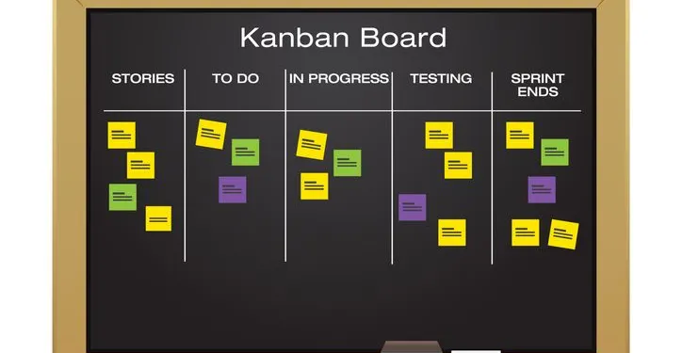

* This visual workflow enables teams to see who is working on a task, which elements of the project are being handled and how the team’s capacity is dispersed. This pull system, whereby work is pulled through completion, either by a team member or a machine, avoids needlessly pushing tasks through based on a pre-established schedule.
* Through Kanban project management to streamline projects and manage tasks based on priority as well as reduce wasted resources and time.
* With this visual management tool, each card represents an individual task, and cards are organized by stage (or section), priority and delivery. For example, stages might be set up as:
  + - Pending
    - In progress
    - Completed

## Change Management and it’s Process

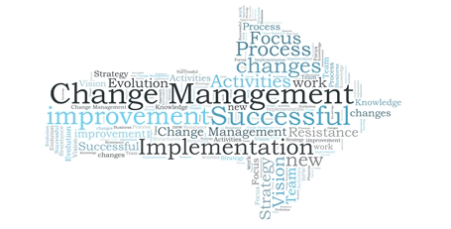

* Change management is a collective term for all approaches to prepare, support, and help individuals, teams, and organizations in making organizational change.
* In a project-management context, the term "change management" may be used as an alternative to change control processes wherein changes to the scope of a project are formally introduced and approved.
* Five building blocks of successful change for an individual:
* Awareness of the need for change
* Desire to participate and support in the change
* Knowledge of what to do during and after the change
* Ability to realize or implement the change as required
* Reinforcement to ensure the results of a change continue

#### STEP INTO CHANGE MANAGEMENT

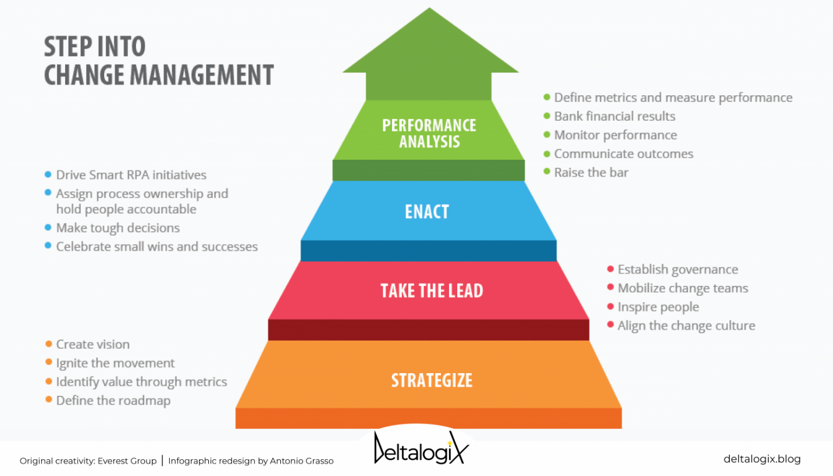

1. **First Stage: strategy considerations**:

In the strategic phase, the impact of actions on people, processes, infrastructure, and workplaces. The result of that assessment will inform what the new direction, goals, and consequently the new vision might be.

1. **Second Step: sharing the vision:**

In the take-charge phase, the roadmap will be shown to the operational managers.

The managers of each department will assess how their department’s processes can be transformed concerning the shared vision. They will need to estimate the resources and technologies already acquired and those that will be needed to initiate change.

1. **Third Phase: operational implementation:**

In the operational phase of a digitalization path, technologies will be the absolute protagonists. A corporate digitalization process cannot ignore, for example, automation or, in some cases, the use of Artificial Intelligence.

1. **Step Four: measuring results:**

In a change as radical as enterprise digitalization, even results can’t be achieved in a short time. However, the important thing is to constantly monitor values indicative of the health of the process to understand if we are on the right track. This is the stage where you highlight the metrics that are useful for measuring performance.

#### Process Flow

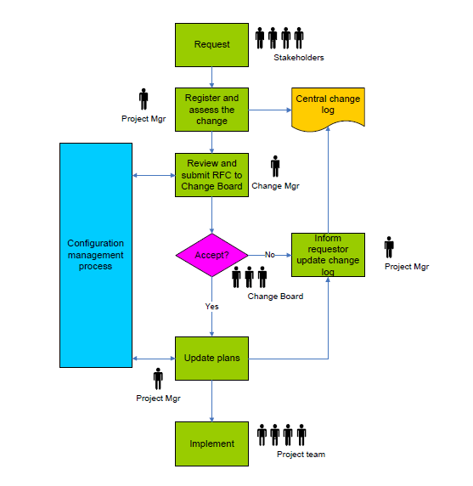

1. **Request for change is made:**

Changes and issues are captured through Project Team meetings, a working group of external stakeholders including other government agencies, meetings of the Project Board, outcomes of approval stages, and monitoring by the Project Team and Project Sponsor.

1. **Register and assess the change:**

Change requests are captured on a central change log that enables monitoring of change levels by the Change Manager.  
  
Once the change is captured the change is assessed by the Project Manager using specialist advice from the Project Team. The Project Manager considers:

* Does it relate to the project?
* Is it really a risk or an issue that can be accepted or dealt with without the change?
* Is it actually a new project?
* Is it required to meet the project goals & KPIs?
* What will happen if the change is not implemented?

1. **Review and submit RFC to the Change Board**

If the change is valid the Project Manager assesses the impact of the change with the project team and submits the change via a Request for Change Form to the Change Manager. It is then submitted to the Change Board which assesses the change and approves or rejects it.

1. **Change Board accepts or rejects the change**

The Change Board includes the client and senior managers who have a strategic overview of the contract. They assess whether the change is within program tolerances and are able to approve most changes. They may look at:

* The effect of the change on the business case,
* The change in relation to the program as a whole,
* Knock on effects of the change,
* Any additional risks related to the change,
* Any lessons that can be learned from the change,
* Any trends that change reveals.

1. **Update plans & implement the change**

Once the change is approved the change log is updated and stakeholders are informed. The Project Manager then works with the project team to plan the implementation of the change; amending the project and stage plans, sourcing any additional equipment or personnel, updating the configuration items, and completing the work package(s).**OOLS &** METHODOLOGIES

#### Governance Model

Building a robust governance model ensuring cross unit communication bringing every stakeholder on same page

**CLIENT NetCreativeMind**

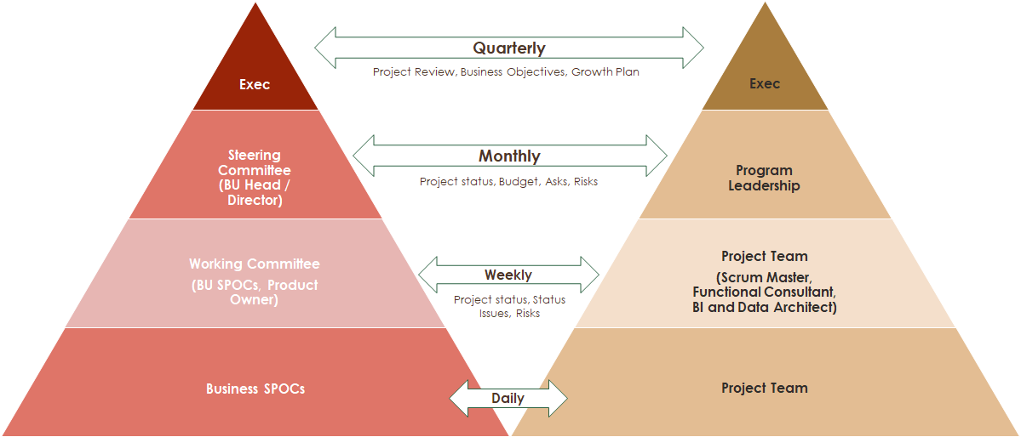

**Communication Process**

We believe in seamless and transparent communication ensuring every involved stakeholders are informed and updated on the progress

**High-level Communication Channels and Frequency**

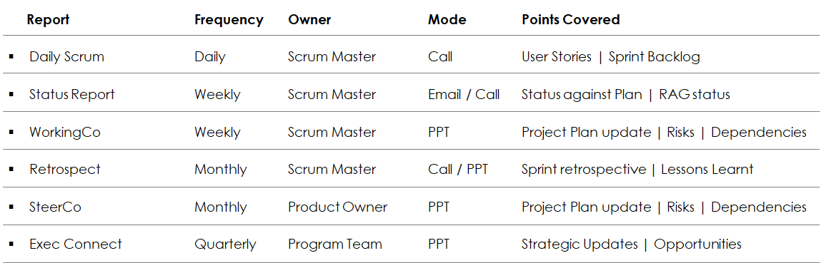

## Roles and Responsibilities

### **Department**

1. No additional functions, features, or modules outside of those listed in the proposed solution shall be introduced for development
2. Designate one or two particular persons for all project-related activities.
3. Ensure all information related to the project is available on time.
4. Speedy feedback on all deliverables, and queries from Department officials.
5. Department approval in every stage is necessary because work for the next stage would only start after approval of the previous stage.
6. Examine and approve the sample layout within one week.
7. Provide complete content for the Portal.
8. Controlling the scope creep (Frequent and uncontrolled changes in the scope or requirements of a project).
9. Well-established and effective communication channels from the Department.
10. Not mentioned in RFP APIs should be provided by the department.

### **Agency**

1. Undertaking development as per the defined schedule.
2. Keeping Department updated on the progress through appropriate status reports.
3. Designating a single point of contact for all communication needs.
4. Assistance and training to Department on the overall solution.
5. Providing technical support to Department for one year for any unforeseen bugs/issues.
6. IA shall provide hosting space for development/UAT.
7. IA shall provide training to the department.

# Appendices

## Format for Sample Progress Report

**PP No: \_\_\_\_\_\_\_\_\_\_\_ User\_\_\_\_\_\_\_\_\_\_\_\_\_\_\_\_\_\_**

**Date: \_\_\_\_\_\_\_\_\_\_\_\_\_\_\_\_\_**

**Fortnightly Progress Report**

|  |  |  |  |
| --- | --- | --- | --- |
| **S.No.** | **Activity** | **Completion Date** | **Remarks** |
|  |  |  |  |
|  |  |  |  |
|  |  |  |  |
|  |  |  |  |

Submitted by:

Signature: \_\_\_\_\_\_\_\_\_\_\_\_\_

Name: \_\_\_\_\_\_\_\_\_\_\_\_\_\_\_\_

Designation: \_\_\_\_\_\_\_\_\_\_\_

Phone: \_\_\_\_\_\_\_\_\_\_\_\_\_\_\_

## Format for Content which is to be stored in a database

The department may submit the duly filled-in form (given below) for each web page separately to the development agency while handing over the content for integration on the website. The content for Hindi language pages must be in Unicode-compliant font e.g. Mangal.

|  |  |
| --- | --- |
| Title of the page |  |
| Major Subject |  |
| Minor Subject |  |
| Sub Minor subject (if any) |  |
| Brief Page Description (For Public Search Engines e.g. Google) |  |
| Metadata (Important Keywords for this page For Public Search Engine e.g. Google) |  |
| File name (soft copy of the content) |  |

Note: Soft copy should be properly formatted in all aspects.

## Format for Content which is to be stored in pdf format

The department may submit the duly filled-in form (given below) for each linked document separately to the development agency while handing over the content for integration on the website.

|  |  |  |
| --- | --- | --- |
| Document Title |  | |
| File type (Output Version)\* |  | |
| File type (Editable Version)\* (note: it may be clearly mentioned in case an editable version is not available |  | |
| File name (both Output & editable version) | Output version | Editable version |
| Brief Document Description (For Public Search Engine for e.g. Google) |  | |
| Meta data(Important Keywords for this page For Public Search Engine for e.g. Google) |  | |

Note: Department needs to submit both versions (English & Hindi) of all the linked documents to the Development Company for ensuring the accessibility of the documents.

## Format for the completion certificate

|  |
| --- |
| eference No.: \_\_\_\_\_\_\_\_\_\_\_\_\_ Date: \_\_\_\_\_\_\_\_\_\_  **COMPLETION CERTIFICATE**  To  The General Manager  NICSI, Hall # 2 & 3, 6th Floor  NBCC Tower, 15- BhikajiCama Place  New Delhi-110066  **Kind Attention: -------------------------------------------------------**  **Sub: Completion Certificate for** <website / web enabled application name>  Dear Sir/Madam,  It is to certify that the Design & Development of Website named \_\_<website name>\_\_ of\_\_<Department name>\_\_having Project ID \_\_<NICSI Project Id>\_\_ and Work Order No. \_\_<NICSI Work Order No.>\_\_dated \_\_<Work Order date>\_\_ has been completed as per the proposal submitted for the website by NISCI on time to our satisfaction.  With Warm regards, |

## Format for Change Request

| **General Information** | | | |
| --- | --- | --- | --- |
| Date: |  | Project ID: |  |
| Project Name: |  | Organization Name: |  |
| Contact Person Name: |  | Contact No: |  |

|  |  |  |  |
| --- | --- | --- | --- |
| **Category:** | | A Editorial modification |  |
|  | | B Addition of a feature |  |
|  | | C Functional modification of a feature |  |
|  | | D Correction |  |
| **Proposed change(s)**: |  | | |
|  | | | |
| **Reason for change:** |  | | |
|  | | | |
| **Consequences if not approved:** |  | | |

## Escalation Matrix

**Email**: manoj@netcreativemind.com

**Contact No**: +91 9810978433

**Manoj Garg**

**(CEO)**

4

**Email**: [rishi.kumar@netcreativemind.com](mailto:rishi.kumar@netcreativemind.com)

**Contact No**: +91 9711119799

Rishi Kumar

(Project Manager)

3

s

**Email**: rohit.tiwari@netcreativemind.com

**Contact No**: +91 9911729706

Rohit Tiwari

(Sales Manager)

2

**Email**: [support@netcreativemind.com](mailto:support@netcreativemind.com)

**Contact No**: 01141689181

Help Desk

1

4

## Terms & Conditions

We accept all terms & conditions as per



**For any further clarifications/inquiries, you may please contact:**

***B-214 2nd Floor Okhla Industrial Area, Phase-I New Delhi 110020***

***Phone: +91 11 41689181***

***New Delhi – 110066, India***  
Email:[*sales@netcreativemind.com*](mailto:sales@netcreativemind.com)  
Website: [*http://www.netcreativemind.com*](http://www.netcreativemind.com)